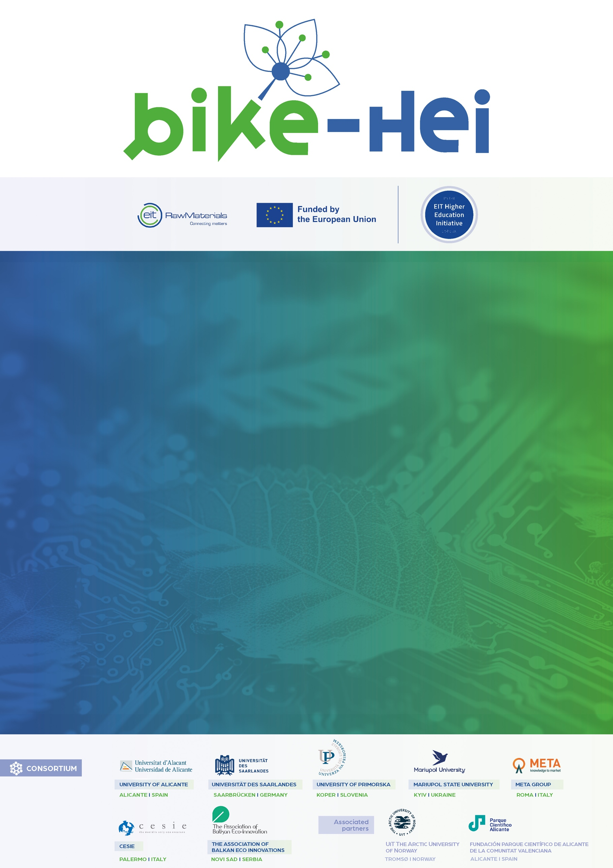

BIKE-HEI Innovation & Entrepreneurship Award – 1st Edition
INSERT CANDIDATE NAME
INSERT NAME OF THE START-UP/SPIN-OFF
INSERT DATE
You are about to complete your official BIKE-HEI Innovation & Entrepreneurship Award 2025 Project Summary. This document is a core part of your application and will be reviewed by the evaluation committee as part of the selection process.
Please fill in this Word template with the requested information. Once completed, you must export it as a PDF file and upload it in the designated section of the Microsoft Forms application portal.
Once completed submit this file to info@bike-hub.eu

Formatting Guidelines
To ensure fairness and consistency across all submissions, please respect the following formatting rules:
- Maximum Length: 5 pages (excluding cover and instructions)
- Font: Arial
- Font Size: 11 pt
- Line Spacing: 1,15
- Margins: 2.5 cm for all sides
- File Format: PDF only (no .docx or .pages files will be accepted)
- File Name: First Name+Last Name_fileA.pdf
Please avoid using excessive images, animations, or design embellishments. Focus on clarity, impact, and relevance to the Award themes (AI, Climate Action, Green Economy).
In order to provide a concise and compelling overview of your start-up or spin-off, this document will outline different sections that should be filled. You can use the guiding questions to help you in the process).
The BIKE-HEI Innovation & Entrepreneurship Award organizers are committed to protecting the confidentiality of all information provided by applicants during the application and evaluation process. All personal and project-related information submitted will be treated as confidential and shared only with the evaluation committee members. Any data collected will not be disclosed to third parties without explicit consent from the applicant, except as required by law. Applicants are encouraged to mark any proprietary or sensitive information as confidential within their submissions. The evaluation committee will take all necessary precautions to prevent unauthorized access to any confidential materials. In addition, applicants must demonstrate personal and professional integrity to be eligible for the award. Submissions associated with unethical content, misleading claims, or illegal activities will be excluded from the selection process.

INTRODUCTION (What to report: 1. Name of the venture; 2. Founding story and your vision; 3. The core innovation at the heart of your project)

INNOVATION (What to report: 1. Explain the solution you’re developing and why it’s innovative; 2. What is the product, service, or technology?; 3. How does it work? ; 4. What makes it different from existing solutions?

MARKET FIT (What to report: 1. Outline the opportunity and the long-term impact; 2. Who are your target customers/users?; 3. What is your market potential? ; 4. How does your solution contribute to sustainability,climate, or digital transformation?

TEAM & GOVERNANCE (What to report: 1. Introduce your team and their capacity to execute; 2. Introduce any mentors or insitutional support; 3.Describe relevant achievements, awards, or credentials; 4. Diversity within the team (e.g., gender diversity and balance, international composition)

ALIGNMENT WITH BIKE-HEI & EIT RAW MATERIALS PRIORITIES (What to report: 1.Demonstrate how your venture fits into the BIKE-HEI and EIT Raw Materials ecosystem; 2. Introduce how participation in this award would help scale your impact. For more information, look into the EIT Raw Materials Strategic Agenda 2021-2027.

